Child and Youth Manager (Maternity Cover 21 hours per week)

Welcome to the Farm
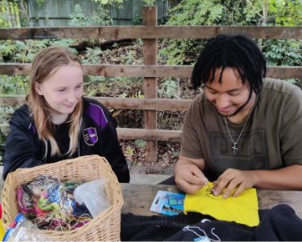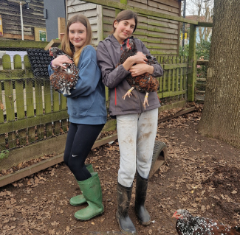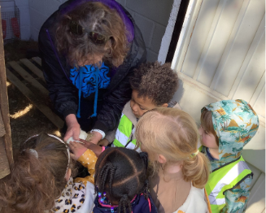
St Werburghs City Farm is a vibrant community hub in the heart of Bristol. We manage a small farm, community garden and conservation area. Our mission is to enhance the skills, health, and build social connections for people of all ages, including those experiencing a range of disadvantages, through volunteering and educational opportunities.

We offer diverse programmes that provide hands-on experience in areas like gardening, animal care, cooking, and conservation. Our work strengthens the bond between land, animals, and people, while recognizing the importance of green spaces for health and wellbeing. Committed to inclusion, we focus on addressing inequalities in access to green space, local food, and agricultural opportunities, particularly for those from disadvantaged or marginalised backgrounds.

The Farm runs daily services for young people struggling in mainstream education, adults with learning disabilities and adults experiencing mental health challenges, social isolation and disadvantage. We also run a small livestock Farm, offer space and site hire and manage 230 community allotments.

The Child and Youth manager leads all our work with young people including alternative learning placements, youth club, holiday activities and school visits along with other short-term or ‘pop-up’ activities.

We are working to create a future where communities grow, green spaces flourish, and together we thrive.

What you will love about working here
- Working in a supportive environment which values your diversity and talent.
- Access to training opportunities and reflective practice.
- Being part of a welcoming team that strives for greater inclusion and equity.
- Flexibility for those with families and other commitments.
- An office based at the Farm, surrounded by allotments. A beautiful, green, community setting.

- Generous annual leave entitlement – 25 days plus bank holidays, pro rata.
- Participation in the NEST pension scheme.
- Access to the cycle-to-work scheme.

About the role
We are looking for an organised and reliable person who can ensure the smooth running of our established Child and Youth project during this period of maternity cover. You will be someone who is passionate about outdoor education and experienced in supporting young people with varying needs to learn new skills, develop their self-esteem and make social connections.

Key Responsibilities
- Oversee the smooth running of the Child and Youth annual timetable of educational sessions.
- Line manage the Child and Youth staff team: supporting staff with planning, ensuring cover is available when needed, leading termly meetings and carrying out supervisions and appraisals.
- Lead/support on planning and curriculum work for the project.
- Session delivery (in a leading role). Lead some sessions with young people including planning, resourcing and delivering.
- Promote and market the project. Continue to build connections with other local professional bodies.
- Liaise with relevant professionals, support workers and parents to assess the needs of young people and put an appropriate programme in place.
- Monitor the ongoing financial sustainability of the service by filling placements, contributing to the development of funding applications and improving the efficiency of delivery.
- Maintain appropriate administrative records, budgetary control and liaise with the Finance Manager to ensure all invoicing is completed each term.
- Monitor progress and outcomes for young people.
- Take responsibility for Health and Safety issues relating to project activities as appropriate including the preparation of activity site checks, risk assessments and safe tool use.
- Prepare annual reports, project plans and regular reports to trustees as requested.
- As a member of the Farm’s Management team, you will collaborate with colleagues to provide insights and guidance related to your expertise, helping the charity to remain impactful and achieve our mission. You will attend fortnightly managers meetings and be added to a rota of weekend on-call Duty Managers (all training required for this will be provided).

Your skill set
- A minimum of two years working with young people with varying needs.
- Experience of flexible planning to create learning environments that are as inclusive as possible.
- Experience of leading and line managing a small team of staff.
- Understanding/experience of project management.
- Experience of planning and implementing a programme of activities for a range of abilities in a practical setting.
- Ability to build and maintain relationships with colleagues, young people and other stakeholders (including referrers, parents and carers).
- Good administrative and organisational skills, including budgetary control and record keeping.
- Proficient in ICT with proven ability to use Microsoft packages include Word and Excel.
- Experience of safeguarding young people.
- A qualification in teaching, Forest school, play work or equivalent.

Your approach
- Reliable, pro-active and self-motivated and ability to think creatively and problem-solve.
- Trauma informed.
- Commitment to person-centred support.
- Reflective of your work and a willingness to learn new skills.
- Able to work independently and prioritise a demanding workload.
- Commitment to inclusion, equity and accessibility.
- Positive, confident and honest in the way that you work.
- Approachable and good at communicating.
- Passionate about what the Farm does.

Other details
Contract type: Maternity Cover
Salary: £27,803 pro rata (actual salary of £16,681.80 for 21 hours per week)
Hours of work: 21 hours per week, over at least 3 days per week, largely undertaken between 9 - 5pm, Monday to Wednesday with some flexibility on days where delivery is not required.
Place of work: This role is based at St Werburghs City Farm in Bristol.
Annual leave: 25 days holiday per year, plus public holidays, pro rata.

Probationary period: The appointment will be subject to a probationary period of 3 months.
References: All appointments will be confirmed only upon receipt of satisfactory references.
Application Deadline: Wednesday 4th March 2026, 10am

The successful candidate will be required to undertake a DBS check for this role. If you have any questions or would like an informal chat about the role, please email: community@swcityfarm.co.uk

