Farm Maintenance and Livestock Officer – 4 days per week (28 hours)

Fixed Term (with a review of the role in July 2027)

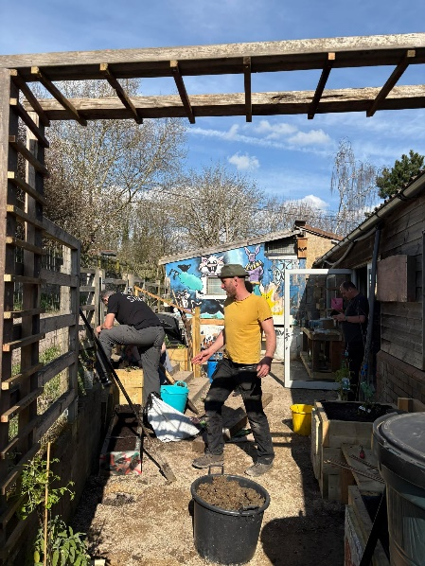
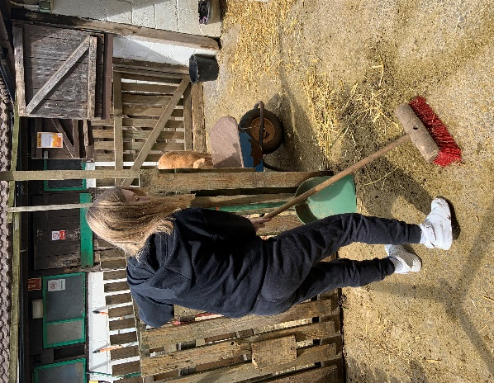
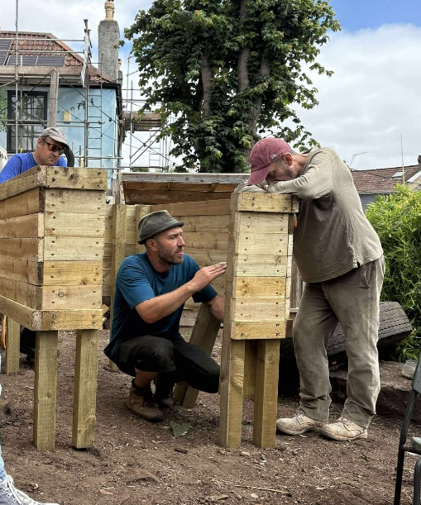

Who we are
St Werburghs City Farm is a vibrant community hub in the heart of Bristol. We manage over 18 acres of green space, including a small farm, community garden, allotments and woodland conservation area. Our mission is to enhance the skills, health, and connections of people of all ages, including those experiencing a range of disadvantages, through volunteering and educational opportunities.
We offer diverse programmes that provide hands-on experience in areas like gardening, animal care, cooking, landscaping and conservation. Our work strengthens the bond between land, animals, and people, while recognising the importance of green spaces for health and wellbeing. Committed to inclusion, we focus on addressing inequalities in access to green space, local food, and agricultural opportunities, particularly for those from disadvantaged or marginalised backgrounds.
We are working to create a future where communities thrive, green spaces flourish, and together we grow.

What you will love about working here
- Working practically on our Farm site and with our animals
- Spending lots of time outdoors and being part of valued community provision
- Working in a supportive environment which values your diversity and talent
- Access to training opportunities and reflective practice
- Being part of a team that strives for greater inclusion and equity
- Flexibility for those with families and other commitments
- Generous annual leave entitlement – 25 days and bank holiday pro rata
- Participation in the NEST pension scheme
- Access to the cycle-to-work scheme
- Dog-friendly office (conditions apply)

About the role
We’re looking for someone with strong practical skills who wants to make a real and lasting difference to people’s lives whilst ensuring that the Farm site and our livestock are at the heart of our work. As the Farm Maintenance and Livestock Officer, you will play an important role in the day-to-day operation of the Farm site, ensuring our facilities are clean, safe and welcoming for beneficiaries and the wider community to access. This includes the following key work areas:

- Support the Sites Operational Manager to maintain and improve the Farms sites, buildings and infrastructure, often working independently to carry out repairs and develop infrastructure across our varied sites and spaces.
- With guidance from the Sites Operational Manager you will lead groups of volunteers to carry out maintenance, carpentry or other practical projects as part of team building days.
- Undertake routine and reactive animal care checks; coordinate the ordering of feed, bedding and other resources as necessary, and support the Livestock Manager with planned animal movements, including transporting animals to the abattoir and arranging the sale of meat.
- Being the lead staff member on site responsible for our animals on particular days, undertaking routine husbandry tasks, supporting breeding programmes and ensuring that we always uphold the highest standards of animal welfare.
- On Tuesdays during term-time you will work with the Child and Youth team to support their animal care session for teenagers. Supporting their lead officer to plan and deliver the Animal Care Alternative Learning Provision - supporting young people to learn about animal care and a range of practical maintenance skills.
- You will work with project managers and other Farm officers to design farm-based activities that increase engagement and practical learning opportunities for project beneficiaries. This includes: considering the needs of people of mixed ages and abilities in activities, developing risk assessments, assisting with sessions, preparing resources and monitoring impact.
- You will work alongside the sites and livestock team to ensure our sites are safe and our health and safety policies and procedures are up to date.
- This is a four day per week (28 hour) role which will ideally involve one weekend day per month and must include Tuesdays.
There is some possibility of this role being extended beyond 12 months, but this is subject to future needs and funding.

Your skill set
- Demonstrable ability to successfully complete practical maintenance tasks (i.e. fencing, basic plumbing, and other basic construction tasks), including safe use of tools.
- Demonstrable experience of farm animal husbandry with a variety of animals, including knowledge of ailments/treatments, or an interest and willingness to learn.
- Ability to plan and deliver maintenance/farm-based activities with participants of all ages and abilities i.e. animal husbandry, basic construction, maintenance etc.
- A willingness to work inclusively with children, young people and adults of all abilities.
- An awareness of safeguarding children and vulnerable adults and willingness to learn.
- A good understanding of Health and Safety which can be applied to a farm setting.
- Planning, administrative and organisational skills.
- A proven ability to work flexibly, independently and as part of a team.
- Strong and inclusive communication skills.
- A clean UK driving license is useful for this role, but not essential.

Your approach
- Commitment to teamwork and flexibility to adapt to organisational priorities
- Reflective of your work and a willingness to learn new skills
- Able to work without being supervised and prioritise a demanding workload
- Commitment to inclusion, equality, and accessibility
- Passionate about animals, nature and our environment

In your first six months you will:
- Learn what St Werburghs City Farm is all about and how our sites help us to achieve our Vision and Values
- Work with the Sites Operational Manager & Livestock Manager to get to know our:
  - Animals and their care needs
  - Sites and maintenance needs
  - Procedures, policies and communication systems
- Develop a good understanding of your role in the Child & Youth Animal Care Sessions.
- Understand the needs of all our different projects/service users and identify how to facilitate increased use of the Farm and engagement with our animals in a safe and inclusive way
- Become confident in responding to visitor enquiries, understanding where to signpost people when necessary.

Deadline for applications: 10am Monday 13th July 2026
Interviews are expected to be held on: Tuesday 21st July 2026

General
We expect all staff to maintain a flexible working ethos, promote the Farm's values, aims and objectives and present a positive image to beneficiaries and the public. All staff are expected to abide by the organisation’s policies and to carry out any other duties commensurate with the responsibilities of their post. The successful candidate will be required to undertake an enhanced DBS check.

Job Title: | Farm Maintenance and Livestock Officer
Responsible to: | Sites Operational Manager
Place of work: | St Werburghs City Farm
Hours of work: | 28 hrs per week, to include Tuesdays
Contract Type: | 1-year Fixed Term
Annual leave: | 25 days plus statutory holidays and bank holidays, pro rata
Probationary period: | 3 months
Starting Salary: | £26,197 pro rata
Pensions: | St Werburghs City Farm offer pensions in line with the NEST scheme

If you have any questions about this opportunity, please contact community@swcityfarm.co.uk

St Werburghs City Farm - inspiring spaces, educating people and connecting communities
Registered Charity Number 297091. Company Limited by Guarantee Number 2114442

